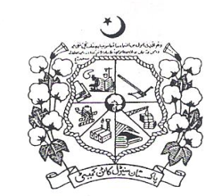 **January,** 2017

Vol. 49 No. 05

Directorate of Marketing & Economic Research

**PAKISTAN CENTRAL COTTON COMMITTEE**

Ministry of Textile Industry, Government of Pakistan

Old Shuja Abad Road, Multan Pakistan.

Phone: +92-61-9201657 Fax: +92-61-9201658

E-mail: [dmer@pccc.gov.pk](mailto:dmer@pccc.gov.pk) Web: [www.pccc.gov.pk](http://www.pccc.gov.pk)

|  |  |  |
| --- | --- | --- |
| Editorial Team  Dr. Muhammad Ali Talpur,  Director  Mrs. Amra Nazim,  Principal Scientific Officer  Mr. Gul Hassan Chandio,  Senior Scientific Officer  Mr. Syed Kamal Ashraf,  Statistical Officer  Miss Sabica Kulsoom,  Computer Operator | Table of Contents | |
| **Domestic Cotton Crop Scenario and First & Second Cotton Crop Assessment** | **01** |
| **Assessment of Cotton Crop, Seed Cotton Arrivals & Seed Cotton Prices** | **02** |
| **Seed Cotton & Cotton Seed Prices** | **03** |
| **Cotton Seed Cake Prices & KCA’s Spot Prices of Raw Cotton** | **04** |
| **Monthly Average Prices of Raw Cotton & Cotton Balance Sheet** | **05** |
| **Cotton Yarn Prices & Statement Showing Exports of Textile Group Commodities** | **06** |
| **Imports of Textile Group Commodities & Economic of Cotton and Competing Crops** | **07** |
| **Export Parity & Import Parity Prices of Seed Cotton** | **08** |
| **Regional Cotton Situation of China , India & International Cotton Situation** | **09** |
| **World Cotton Balance Sheet & Cotton Production, Consumption in Major Countries** | **10** |
| **Cotlook ‘A’ Index Prices** | **11** |
| **New York Cotton Futures** | **12** |
| **Description of Rating of Different Fiber Characteristics** | **13** |
|  | **Weight & Measurement** | **14** |