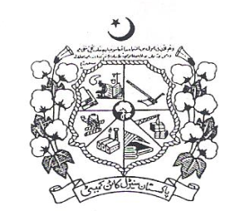 **March,** **2017**

Vol. 49 No. 07

Directorate of Marketing & Economic Research

**PAKISTAN CENTRAL COTTON COMMITTEE**

Ministry of Textile Industry, Government of Pakistan

Old Shuja Abad Road, Multan Pakistan.

Phone: +92-61-9201657 Fax: +92-61-9201658

E-mail: [dmer@pccc.gov.pk](mailto:dmer@pccc.gov.pk) Web: [www.pccc.gov.pk](http://www.pccc.gov.pk)

|  |  |  |
| --- | --- | --- |
| Editorial Team  Dr. Muhammad Ali Talpur,  Director  Mr. Gul Hassan Chandio,  Senior Scientific Officer  Mr. Syed Kamal Ashraf,  Statistical Officer | Table of Contents | |
| **Domestic Cotton Crop Scenario and First & Second Cotton Crop Assessment** | **01** |
| **Assessment of Cotton Crop, Seed Cotton Arrivals & Seed Cotton Prices** | **02** |
| **Seed Cotton & Cotton Seed Prices** | **03** |
| **Cotton Seed Cake Prices & KCA’s Spot Prices of Raw Cotton** | **04** |
| **Monthly Average Prices of Raw Cotton & Cotton Balance Sheet** | **05** |
| **Cotton Yarn Prices & Statement Showing Exports of Textile Group Commodities** | **06** |
| **Imports of Textile Group Commodities & Economic of Cotton and Competing Crops** | **07** |
| **Export Parity & Import Parity Prices of Seed Cotton** | **08** |
| **Regional Cotton Situation of China , India & International Cotton Situation** | **09** |
| **World Cotton Balance Sheet & Cotton Production, Consumption in Major Countries** | **10** |
| **Cotlook ‘A’ Index Prices** | **11** |
| **New York Cotton Futures** | **12** |
| **Description of Rating of Different Fiber Characteristics** | **13** |
|  | **Weight & Measurement** | **14** |